**UCID: 2024510001 BATCH: A NAME: Atharva Vasant Angre**

**EXPERIMENT NO: 08**

**EXPERIMENT TITLE:** To implement Dijkstra Algorithm problem

5.1 To implement Dijkstra Algorithm problem.

**Objective:**

1. To understand the concept of shortest path in a weighted graph.
2. To implement Dijkstra’s Algorithm to find the shortest path from a given source vertex to a target vertex.
3. To display the path taken and cumulative weights at each step.

**Program code:** -

import java.util.*;  
  
public class DijkstraAlgorithm {  
  
 static class Edge {  
 int target, weight;  
 Edge(int target, int weight) {  
 this.target = target;  
 this.weight = weight;  
 }  
 }  
  
 public static void dijkstra(List<List<Edge>> graph, int source, int target) {  
 int n = graph.size();  
 int[] distance = new int[n];  
 int[] parent = new int[n];  
 boolean[] visited = new boolean[n];  
  
 Arrays.*fill*(distance, Integer.*MAX_VALUE*);  
 Arrays.*fill*(parent, -1);  
 distance[source] = 0;  
  
 PriorityQueue<int[]> pq = new PriorityQueue<>(Comparator.*comparingInt*(a -> a[1]));  
 pq.offer(new int[] {source, 0});  
  
 while (!pq.isEmpty()) {  
 int[] current = pq.poll();  
 int node = current[0];  
  
 if (visited[node]) continue;  
 visited[node] = true;  
  
 for (Edge edge : graph.get(node)) {  
 if (distance[edge.target] > distance[node] + edge.weight) {  
 distance[edge.target] = distance[node] + edge.weight;  
 parent[edge.target] = node;  
 pq.offer(new int[] {edge.target, distance[edge.target]});  
 }  
 }  
 }  
  
 if (distance[target] == Integer.*MAX_VALUE*) {  
 System.*out*.println("No path found from " + source + " to " + target);  
 return;  
 }  
  
 // Build path from source to target  
 List<Integer> path = new ArrayList<>();  
 for (int node = target; node != -1; node = parent[node]) {  
 path.add(node);  
 }  
 Collections.*reverse*(path);  
  
 // Print vertex path  
 System.*out*.print("Path: ");  
 for (int i = 0; i < path.size(); i++) {  
 System.*out*.print(path.get(i));  
 if (i < path.size() - 1) System.*out*.print(" -> ");  
 }  
  
 // Print cumulative weights  
 System.*out*.print("\nWeighted Path: ");  
 int sum = 0;  
 System.*out*.print(sum);  
 for (int i = 1; i < path.size(); i++) {  
 int u = path.get(i - 1);  
 int v = path.get(i);  
 for (Edge edge : graph.get(u)) {  
 if (edge.target == v) {  
 sum += edge.weight;  
 break;  
 }  
 }  
 System.*out*.print(" -> " + sum);  
 }  
  
 System.*out*.println();  
 }  
  
 public static void main(String[] args) {  
 Scanner scanner = new Scanner(System.*in*);  
  
 // Input number of vertices and edges  
 System.*out*.print("Enter number of vertices: ");  
 int v = scanner.nextInt();  
 System.*out*.print("Enter number of edges: ");  
 int e = scanner.nextInt();  
  
 List<List<Edge>> graph = new ArrayList<>();  
 for (int i = 0; i < v; i++) graph.add(new ArrayList<>());  
  
 // Input edges  
 System.*out*.println("Enter edges in format: source target weight");  
 int lastTarget = -1;  
 for (int i = 0; i < e; i++) {  
 int src = scanner.nextInt();  
 int tgt = scanner.nextInt();  
 int wgt = scanner.nextInt();  
 graph.get(src).add(new Edge(tgt, wgt));  
 lastTarget = tgt; // Keep updating to get the last entered vertex  
 }  
  
 // Input source vertex  
 System.*out*.print("Enter source vertex: ");  
 int source = scanner.nextInt();  
  
 System.*out*.println();  
 *dijkstra*(graph, source, lastTarget);  
  
 scanner.close();  
 }  
}

**Output:**

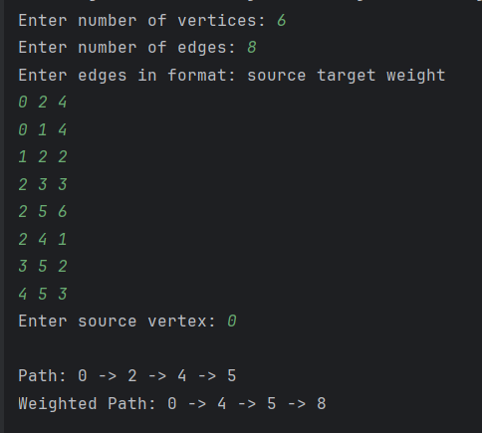

**Conclusion:**

In this experiment, we successfully implemented Dijkstra’s Algorithm to find the shortest path from a source vertex to a target vertex in a weighted graph. We also displayed both the path and the cumulative weights at each step. This experiment helped us understand how greedy algorithms and priority queues can be effectively used to solve shortest path problems in real-world scenarios like network routing and map navigation.